**CASE STUDY**

**Introduction**

Danny seriously loves Japanese food so in the beginning of 2021, he decides to embark upon a risky venture and opens up a cute little restaurant that sells his 3 favourite foods: sushi, curry and ramen.

Danny’s Diner is in need of your assistance to help the restaurant stay afloat - the restaurant has captured some very basic data from their few months of operation but have no idea how to use their data to help them run the business.

**Problem Statement**

Danny wants to use the data to answer a few simple questions about his customers, especially about their visiting patterns, how much money they’ve spent and also which menu items are their favourite. Having this deeper connection with his customers will help him deliver a better and more personalised experience for his loyal customers.

He plans on using these insights to help him decide whether he should expand the existing customer loyalty program - additionally he needs help to generate some basic datasets so his team can easily inspect the data without needing to use SQL.

Danny has provided you with a sample of his overall customer data due to privacy issues - but he hopes that these examples are enough for you to write fully functioning SQL queries to help him answer his questions!

The basic schema would consist of 3 entities

Sales

Menu

Members

**Database Diagram**

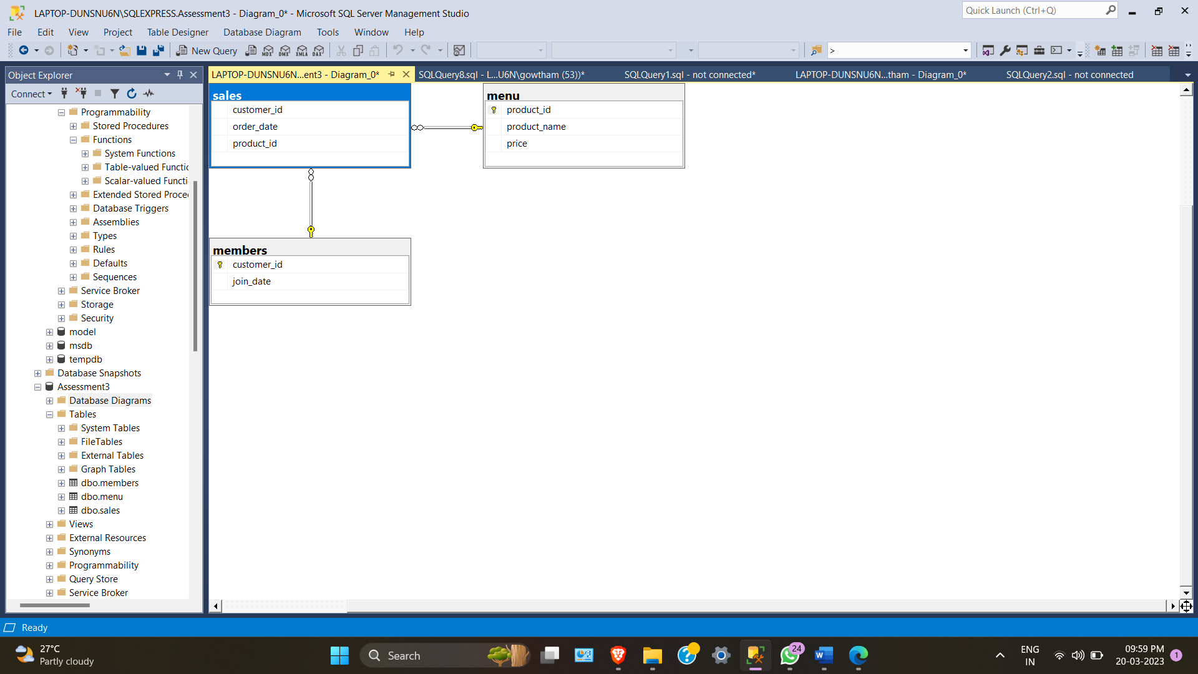

use Assessment3;

CREATE TABLE menu (

"product_id" INTEGER,

"product_name" VARCHAR(5),

"price" INTEGER

);

INSERT INTO menu

("product_id", "product_name", "price")

VALUES

('1', 'sushi', '10'),

('2', 'curry', '15'),

('3', 'ramen', '12');

CREATE TABLE members (

"customer_id" VARCHAR(1),

"join_date" DATE

);

INSERT INTO members

("customer_id", "join_date")

VALUES

('A', '2023-01-07'),

('B', '2023-01-09');

CREATE TABLE sales (

"customer_id" VARCHAR(1),

"order_date" DATE,

"product_id" INTEGER,

constraint fk_members foreign key("customer_id") references members("customer_id"),

constraint fk_menu foreign key("product_id") references menu("product_id")

);

select * from sales;

INSERT INTO sales

("customer_id", "order_date", "product_id")

VALUES

('A', '2023-01-01', '1'),

('A', '2023-01-01', '2'),

('A', '2023-01-07', '2'),

('A', '2023-01-10', '3'),

('A', '2023-01-11', '3'),

('A', '2023-01-11', '3'),

('B', '2023-01-01', '2'),

('B', '2023-01-02', '2'),

('B', '2023-01-04', '1'),

('B', '2023-01-11', '1'),

('B', '2023-01-16', '3'),

('B', '2023-02-01', '3'),

('C', '2023-01-01', '3'),

('C', '2023-01-01', '3'),

('C', '2023-01-07', '3');

Select *From members

Select *From menu

Select *From Sales

ANSWER THE FOLLOWING QUERIES

1. What is the total amount each customer spent at the restaurant?

Select S.customer_id, Sum(M.price) As Used_up

From menu m

join Sales s

On m.product_id = s.product_id

group by S.customer_id

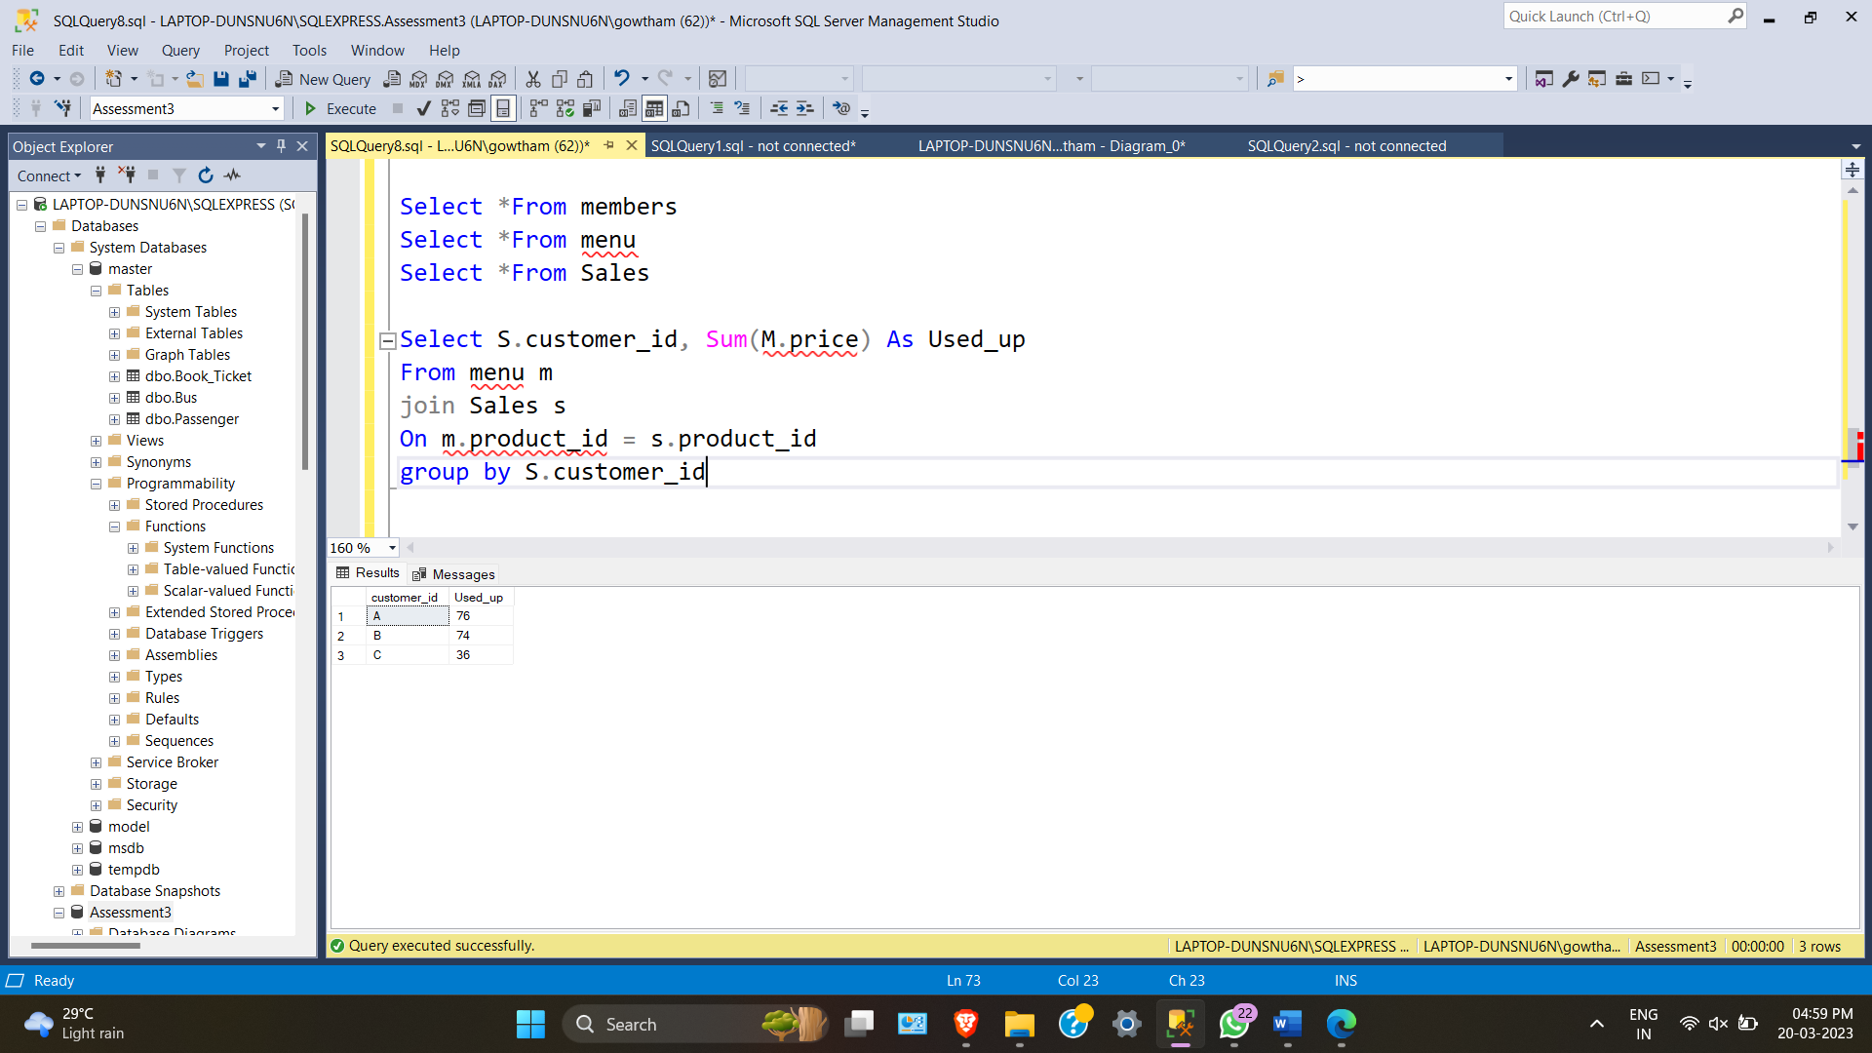

1. How many days has each customer visited the restaurant?

Select customer_id, count(distinct(order_date)) AS day_count

From Sales

Group by customer_id

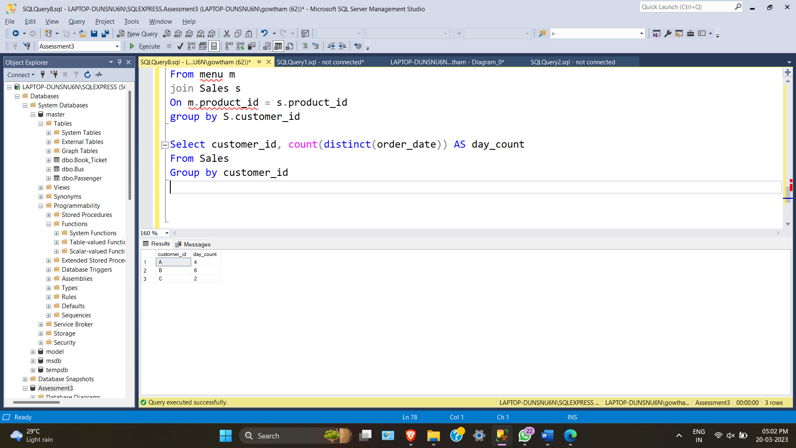Which item was the most popular for each customer?

1. Which item was purchased first by the customer after they became a member?
2. Which item was purchased just before the customer became a member?
3. What is the total items and amount spent for each member before they became a member?
4. If each $1 spent equates to 10 points and sushi has a 2x points multiplier - how many points would each customer have?
5. In the first week after a customer joins the program (including their join date) they earn 2x points on all items, not just sushi - how many points do customer A and B have at the end of January?
6. What was the first item from the menu purchased by each customer?

WITH ordered_sales_cte AS

(

SELECT

customer_id,

order_date,

product_name,

DENSE_RANK() OVER(PARTITION BY s.customer_id ORDER BY s.order_date) AS rank

FROM dbo.sales AS s

JOIN dbo.menu AS m

ON s.product_id = m.product_id

)

SELECT

customer_id,

product_name

FROM ordered_sales_cte

WHERE rank = 1

GROUP BY customer_id, product_name;

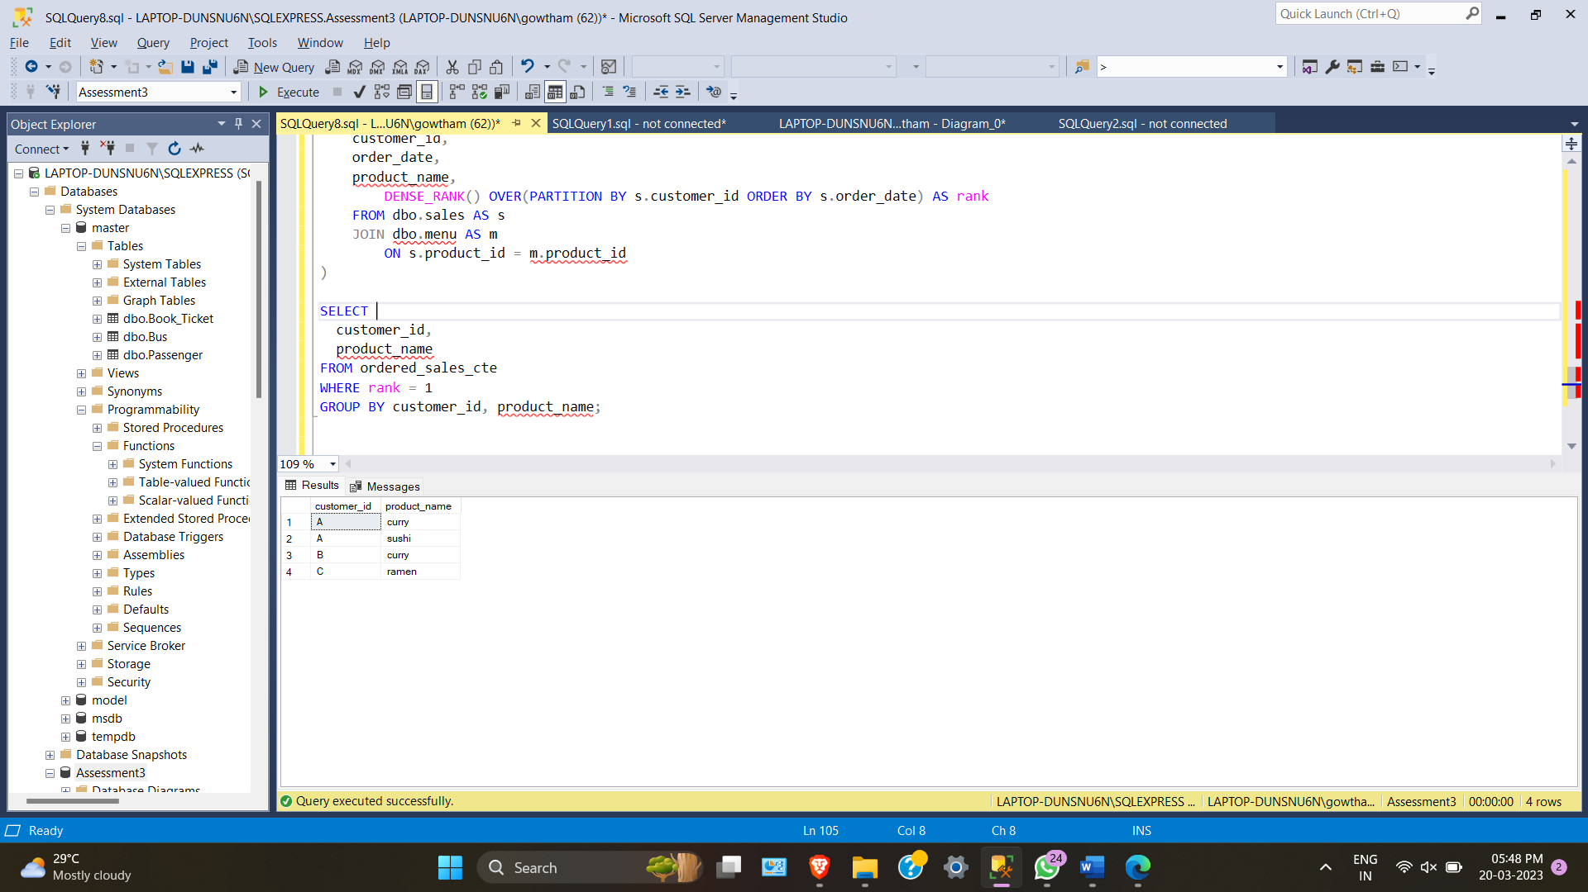

1. What is the most purchased item on the menu and how many times was it purchased by all customers?

SELECT

TOP 1 (COUNT(s.product_id)) AS most_purchased,

product_name

FROM dbo.sales AS s

JOIN dbo.menu AS m

ON s.product_id = m.product_id

GROUP BY s.product_id, product_name

ORDER BY most_purchased DESC;

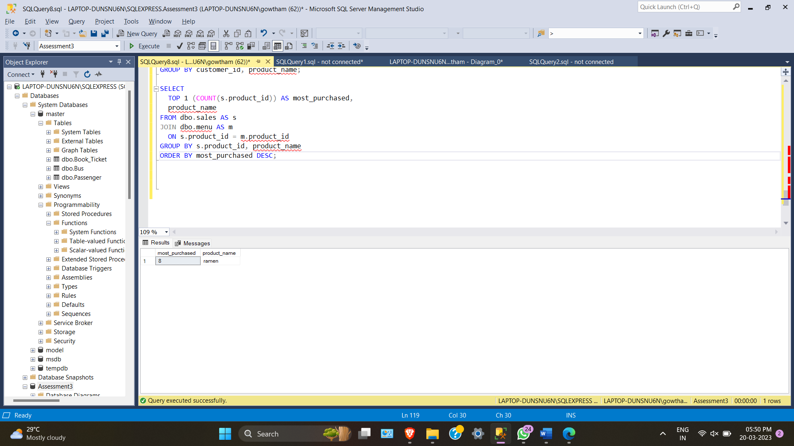

5)Which item was the most popular for each customer?

WITH fav_item_cte AS

(

SELECT

s.customer_id,

m.product_name,

COUNT(m.product_id) AS order_count,

DENSE_RANK() OVER(PARTITION BY s.customer_id ORDER BY COUNT(s.customer_id) DESC) AS rank

FROM dbo.menu AS m

JOIN dbo.sales AS s

ON m.product_id = s.product_id

GROUP BY s.customer_id, m.product_name

)

SELECT

customer_id,

product_name,

order_count

FROM fav_item_cte

WHERE rank = 1;

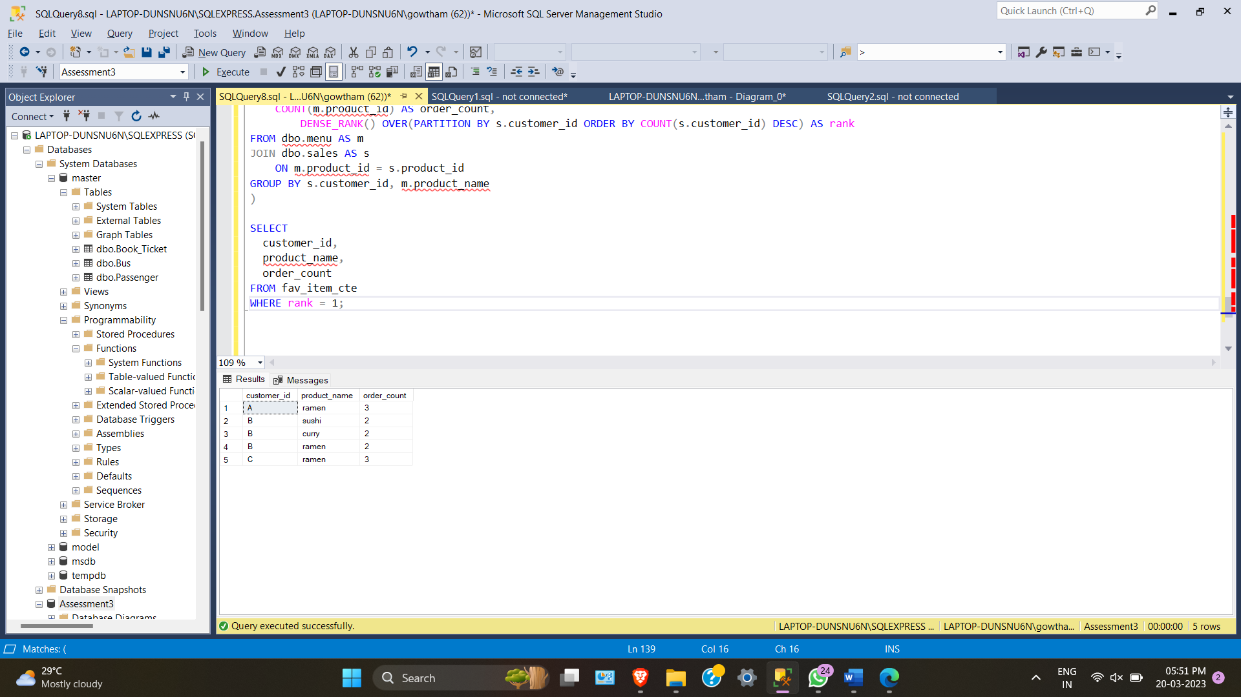

6)Which item was purchased first by the customer after they became a member?

WITH member_sales_cte AS

(

SELECT

s.customer_id,

m.join_date,

s.order_date,

s.product_id,

DENSE_RANK() OVER(PARTITION BY s.customer_id ORDER BY s.order_date) AS rank

FROM sales AS s

JOIN members AS m

ON s.customer_id = m.customer_id

WHERE s.order_date >= m.join_date)

SELECT

s.customer_id,

s.order_date,

m2.product_name

FROM member_sales_cte AS s

JOIN menu AS m2

ON s.product_id = m2.product_id

WHERE rank = 1;

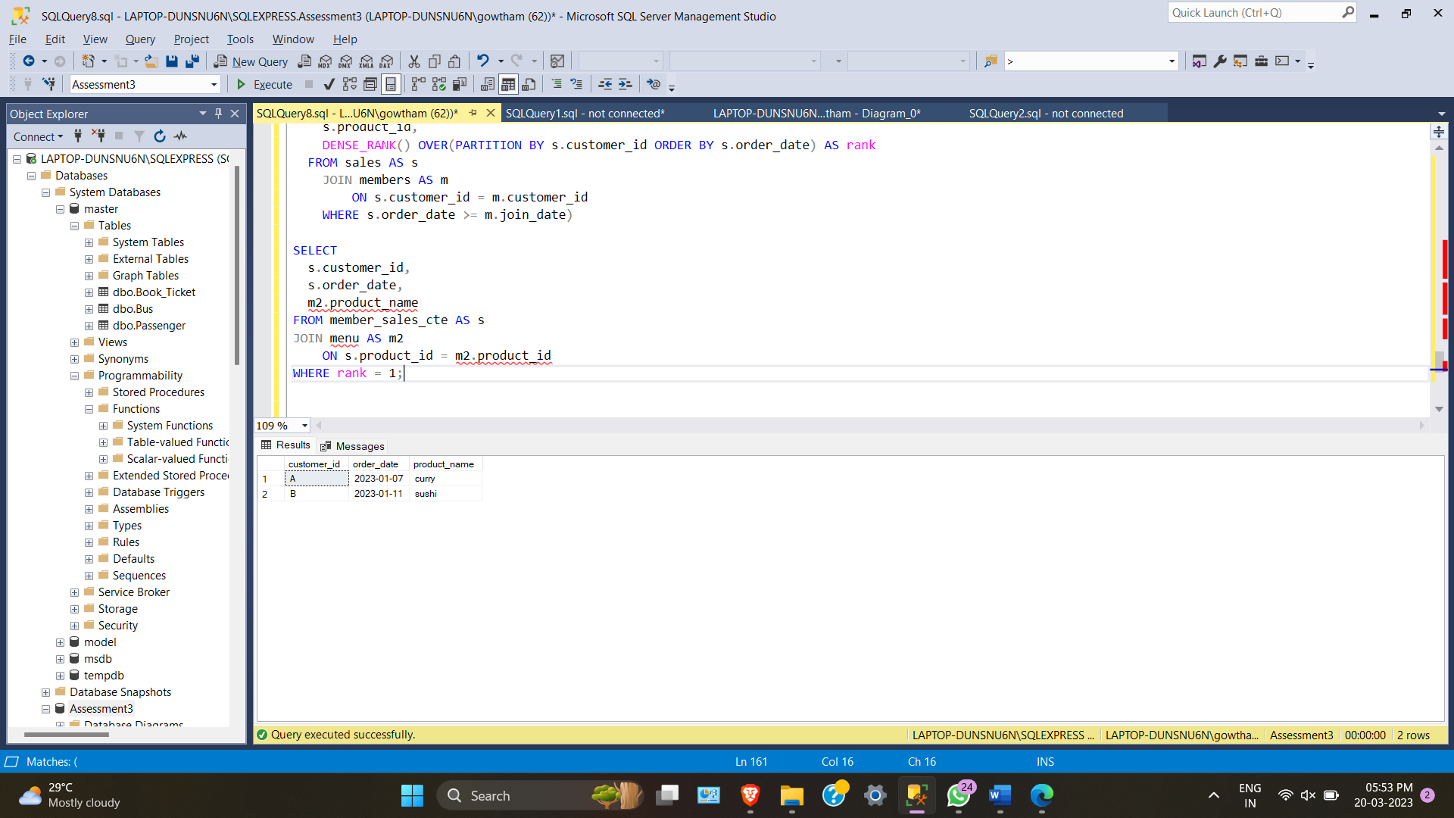

7)Which item was purchased just before the customer became a member?

WITH prior_member_purchased_cte AS

(

SELECT

s.customer_id,

m.join_date,

s.order_date,

s.product_id,

DENSE_RANK() OVER(PARTITION BY s.customer_id ORDER BY s.order_date DESC) AS rank

FROM sales AS s

JOIN members AS m

ON s.customer_id = m.customer_id

WHERE s.order_date < m.join_date

)

SELECT

s.customer_id,

s.order_date,

m2.product_name

FROM prior_member_purchased_cte AS s

JOIN menu AS m2

ON s.product_id = m2.product_id

WHERE rank = 1;

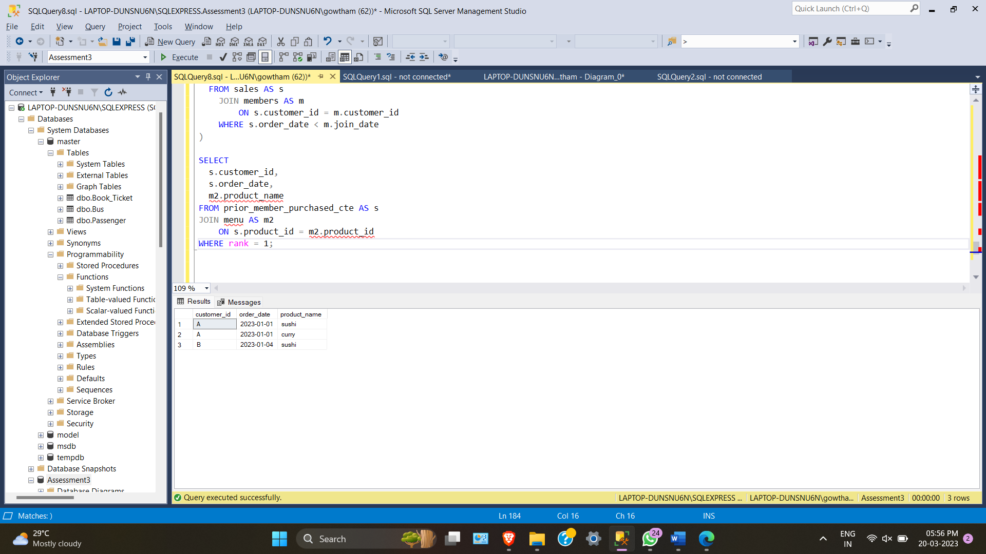

8)What is the total items and amount spent for each member before they became a member?

SELECT

s.customer_id,

COUNT(DISTINCT s.product_id) AS unique_menu_item,

SUM(mm.price) AS total_sales

FROM sales AS s

JOIN members AS m

ON s.customer_id = m.customer_id

JOIN menu AS mm

ON s.product_id = mm.product_id

WHERE s.order_date < m.join_date

GROUP BY s.customer_id

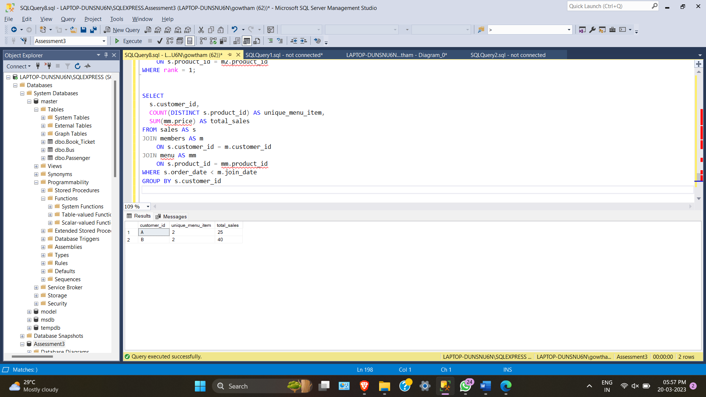

9)If each $1 spent equates to 10 points and sushi has a 2x points multiplier - how many points would each customer have?

WITH price_points_cte AS

(

SELECT *,

CASE WHEN product_name = 'sushi' THEN price * 20

ELSE price * 10 END AS points

FROM menu

)

SELECT

s.customer_id,

SUM(p.points) AS total_points

FROM price_points_cte AS p

JOIN sales AS s

ON p.product_id = s.product_id

GROUP BY s.customer_id

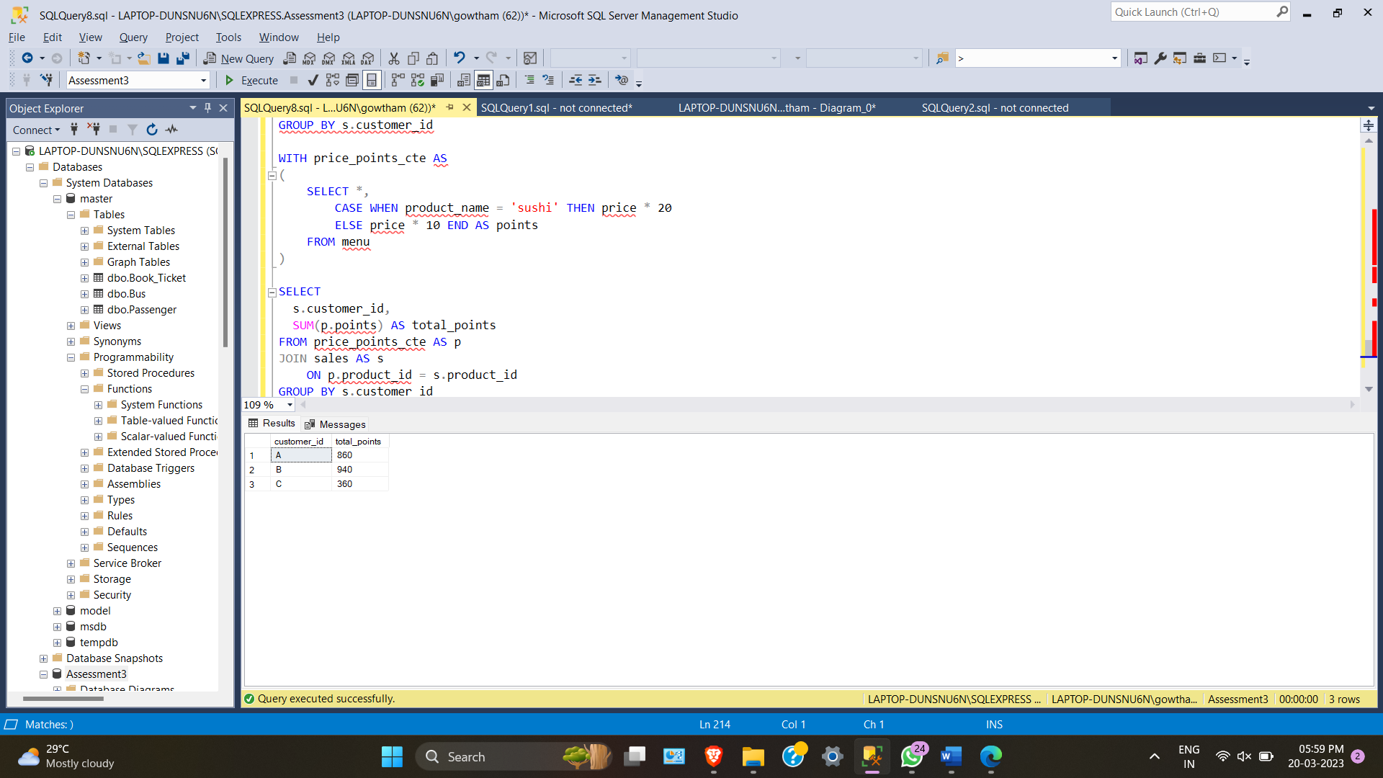

10)In the first week after a customer joins the program (including their join date) they earn 2x points on all items, not just sushi - how many points do customer A and B have at the end of January?

-- 1. Find member validity date of each customer and get last date of January

-- 2. Use CASE WHEN to allocate points by date and product id

-- 3. SUM price and points

WITH dates_cte AS

(

SELECT

*,

DATEADD(DAY, 6, join_date) AS valid_date,

EOMONTH('2023/04/05') AS last_date

FROM members AS m

)

SELECT

d.customer_id, s.order_date, d.join_date, d.valid_date, d.last_date, m.product_name,

m.price,

SUM(

CASE WHEN m.product_name = 'sushi' THEN 2 * 10 * m.price

WHEN s.order_date BETWEEN d.join_date AND d.valid_date THEN 2 * 10 * m.price

ELSE 10 * m.price END) AS points

FROM dates_cte AS d

JOIN sales AS s

ON d.customer_id = s.customer_id

JOIN menu AS m

ON s.product_id = m.product_id

WHERE s.order_date < d.last_date

GROUP BY d.customer_id, s.order_date, d.join_date, d.valid_date, d.last_date, m.product_name, m.price

